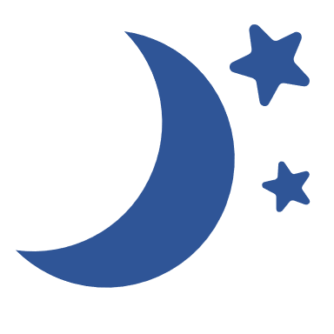

When your chart is complete, return it to your nursery

or school to receive your Toothbrushing Certificate!

Checkmark with solid fill **Tick each box when you have brushed your teeth at home.**

**Brush your teeth at home twice a day. Once before bed and one other time,**

**as well as brushing at nursery or school.**

Don’t forget to keep going!

Home Toothbrushing Chart

Get into the toothbrushing habit!

Monday

Friday

Sunday

Wednesday

Thursday

Saturday

Tuesday

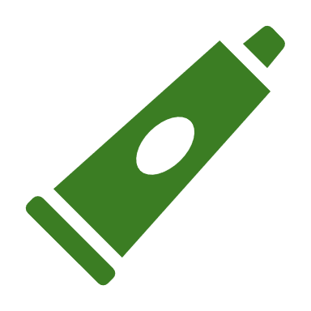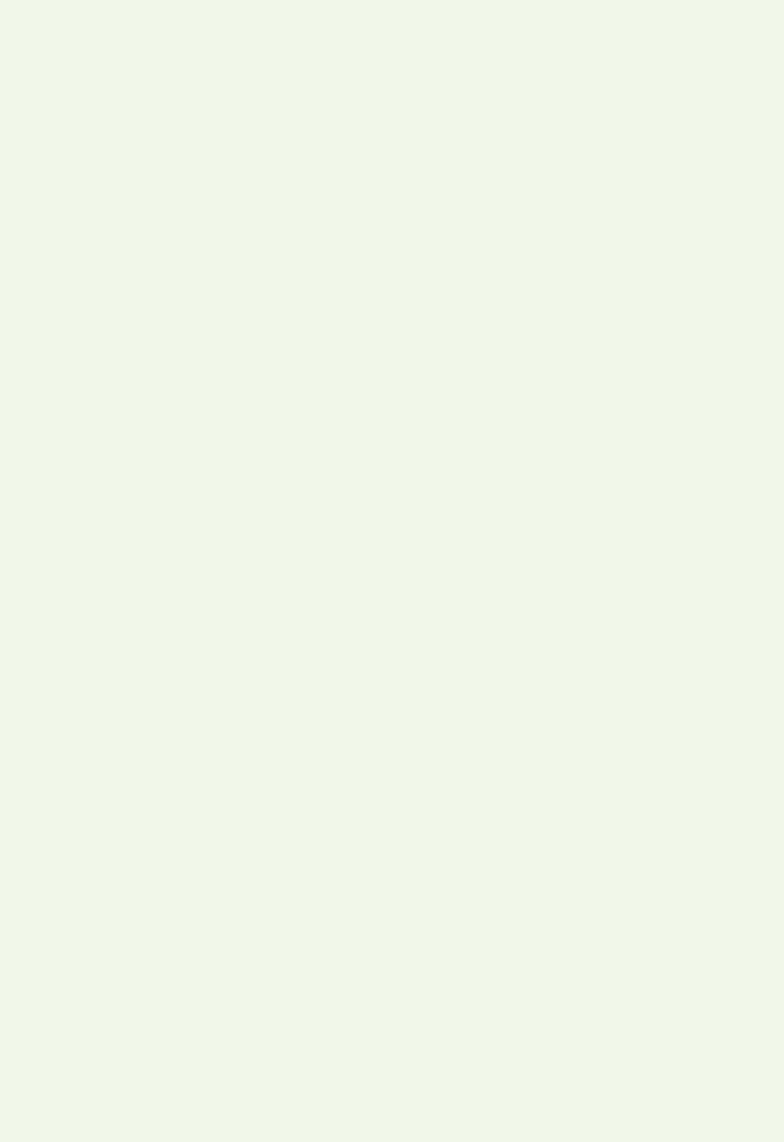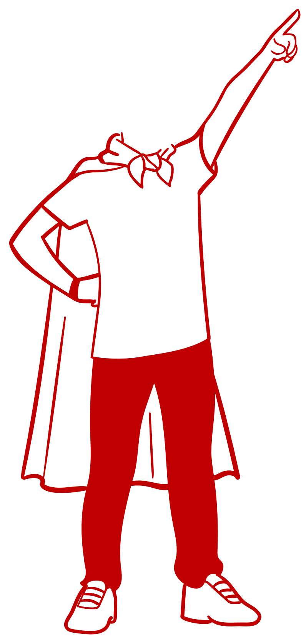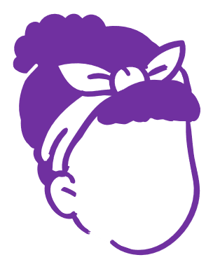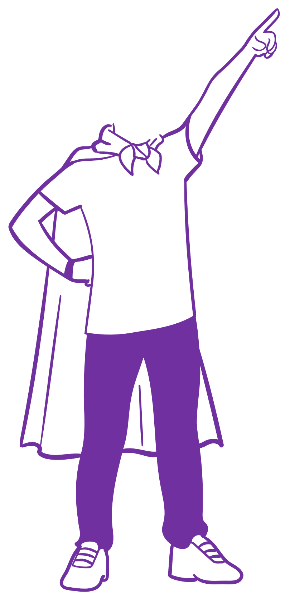

Toothbrush ng

Certificate

**Well done!**

This is to certify that _______________ is into the toothbrushing habit and is brushing their teeth twice a day to keep them sparkly and white!